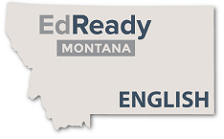
DAILY EDREADY MONTANA GOAL SHEET
Date:
Unit and Topic:
Incoming EdReady Score:
Goal for today’s learning: (Examples: Watch video, talk with teacher, work in a small group, take assessment, review for in-class test)
Did you reach your goal for today? Why or why not?

DAILY EDREADY MONTANA GOAL SHEET
Date:
Unit and Topic:
Incoming EdReady Score:
Goal for today’s learning: (Examples: Watch video, talk with teacher, work in a small group, take assessment, review for in-class test)
Did you reach your goal for today? Why or why not?

